**Batch: D2 Roll No.: 16010221038**

**Student name: Eshan Kalp Trivedi**

**Experiment / assignment / tutorial No. 1**

**Grade: AA / AB / BB / BC / CC / CD / DD**

**Signature of the Staff In-charge with date**

|  |
| --- |
| **TITLE:** Write a program for:  a. Program to find area and circumference of various Geometric shapes.  b. Program to calculate EMI (Equated Monthly Instalment) of loan amount if principal, rate of interest and time in years is given by the user. (E = (P.r.(1+r)n ) / ((1+r)n – 1) |

**AIM:** Write a program for:

a. Program to find area and circumference of various Geometric shapes.

b. Program to calculate EMI (Equated Monthly Instalment) of loan amount if principal, rate of interest and time in years is given by the user. (E = (P.r.(1+r)n ) / ((1+r)n -1)

**____________________________________________________________**

**Expected OUTCOME of Experiment:**

1. **The Area and Circumference is calculated based upon the Radius entered by the user.**
2. **The Equated Monthly Installment (EMI) is calculated based upon the Principal amount, Rate of Interest and Time period entered by the user.**

**_____________________________________________________________________**

**Books/ Journals/ Websites referred:**

1. Programming in ANSI C, E. Balagurusamy, 7 th Edition, 2016, McGraw-Hill Education, India.
2. Structured Programming Approach, Pradeep Dey and Manas Ghosh, 1 st Edition, 2016, Oxford University Press, India.
3. Let Us C, Yashwant Kanetkar, 15th Edition, 2016, BPB Publications, India.

**Problem Definition:**

**Problem 1**: Area and Circumference of any shape (**will be given by instructor**) (example Circle)

Ask user to enter the value of radius of a circle.  Put the values in the formula for ;

finding area of a circle and circumference of a circle and print the outcome for area of a circle and circumference of a circle

**Problem Definition:**

**Problem 2:** Calculating EMI

Ask the user to enter the value of principle amount, rate of interest and time (in years). Store the value in E and print the final monthly instalment E as an outcome.

Formula to be used: E = (P.r.(1+r) n) / ((1+r) n – 1)

**Flowchart:**

**Problem 1:**

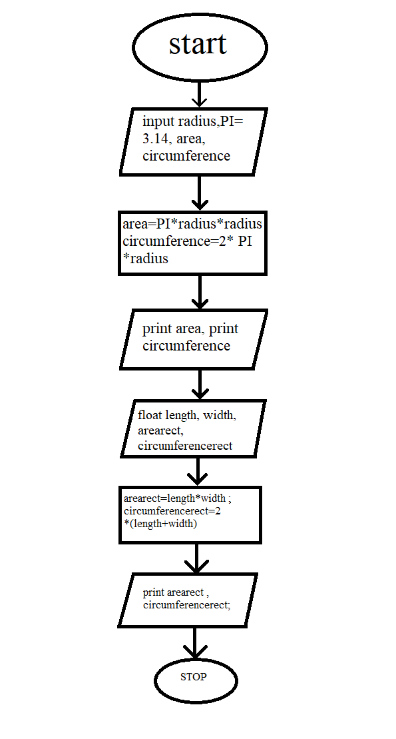

**Problem 2:**

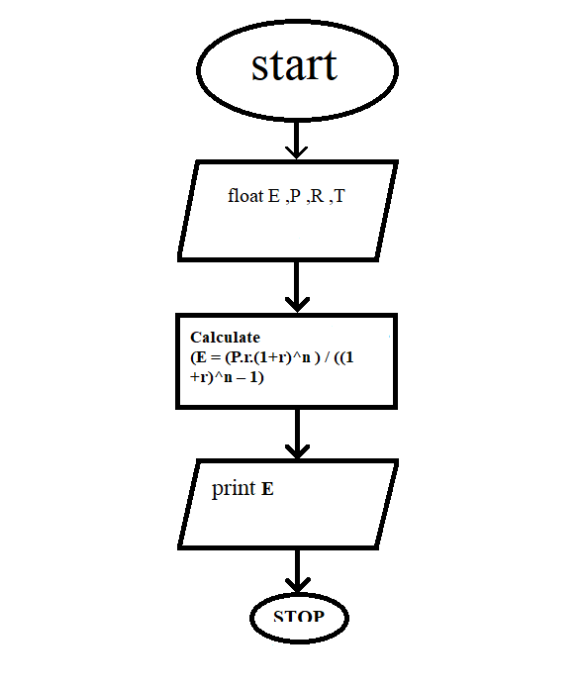

**Implementation details:**

**Problem 1:**

**Code:**

#include<stdio.h>

int main()

{

int radius;

float PI = 3.14, area, circumference;

printf("\nEnter radius of circle: ");

scanf("%d", &radius);

area = PI * radius * radius;

printf("\nArea of circle : %f ", area);

circumference = 2 * PI * radius;

printf("\nCircumference : %f ", circumference);

float length, width, arearect, circumferencerect;

printf("\nEnter the length of the rectangle :");

scanf("%f", &length);

printf("Enter the width of the rectangle :");

scanf("%f", &width);

arearect = length * width;

circumferencerect = 2 *(length + width);

printf("\nThe area of the rectangle is %f.", arearect);

printf("\nThe circumference of the rectangle is %f.", circumferencerect);

return 0;

}

**Output(s):**

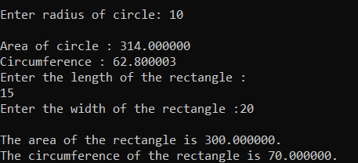

**Implementation details:**

**Problem 2:**

**Code:**

#include <stdio.h>

#include <math.h>

int main()

{

float E , P , R , T ;

printf("Enter the amount of loan \n :");

scanf("%f",&P);

printf("Enter the rate of Interest \n :");

scanf("%f" ,&R);

printf("Enter the number of Years \n :");

scanf("%f" ,&T);

E=((P*R*pow(1+R,T))/(pow(1+R,T)-1));

printf("The EMI on loan amount is %f \n ", E);

return 0;

}

**Output(s):**

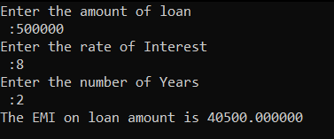

**Conclusion:**

Successful Implementation of Two codes and stated their output correctly. And studied flowchart’s for the same codes.

**Post Lab Descriptive Questions**

1. **Describe problem definition phase with one case study.**

The Problem Definition phase helps us to define a problem and analyse it, so it becomes more easier to implement it, it helps to make a problem at its simplest form for the most suitable outcome through the particular course of solving the problem.

It analyses the inputs from the user, all the data required for the output and processes these data received to give output.

Example: The problem definition phase for Area of a shape will analyse the input i.e., the length and width. It ensures that the data entered is in correct form and format, if any of these goes wrong, we won’t be able to get correct output. It analyses the formulas used and their processing and all their requirements are met successfully and finally stores the output in variable assigned.

1. **What is a flowchart? What are the standard symbols used to draw a flow chart? Explain in brief.**

A flowchart is basically a schematic representation of a program in form of shapes and each shape is assigned a specific function. A flowchart needs to be in a particular format and symbols used are connected using Arrow. A flowchart makes us easy to understand the working and the flow of an algorithm or a code, it depicts the directional flow of code.

The standard symbols used in a basic flowchart are ;

Oval: To start and stop a flowchart.

Rectangle; to depict the process or calculations

Rhombus / parallelogram (or sometimes called diamond): to show the inputs and outputs to the program

Circle(connector): to show the continuation of a flowchart on another side or page.

Arrow: to connect and show the flow of whole flowchart.

Oval:

Rectangle:

Rhombus / parallelogram (or sometimes called diamond):

Circle:

Arrow:

**Date: _____________ Signature of faculty in-charge**